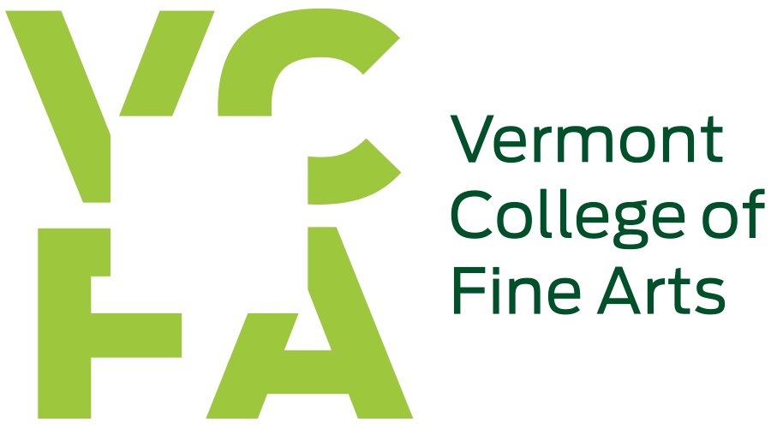

Title IX - Information Packet

Please reference VCFA full Sexual Misconduct Policy here. This information is not intended to substitute for the full policy, but to provide additional information.

How and to whom can an alleged offense be reported?
Reports can be made in person to the title IX coordinator, via email title9@vcfa.edu, or through the Sexual Misconduct and Title IX Report Form.

Additional information about how the process works:

Options regarding notifying/involving law enforcement, campus authorities, available resources both at the institution and in the community.

Options for reasonably available assistance and accommodations and how to request them.

