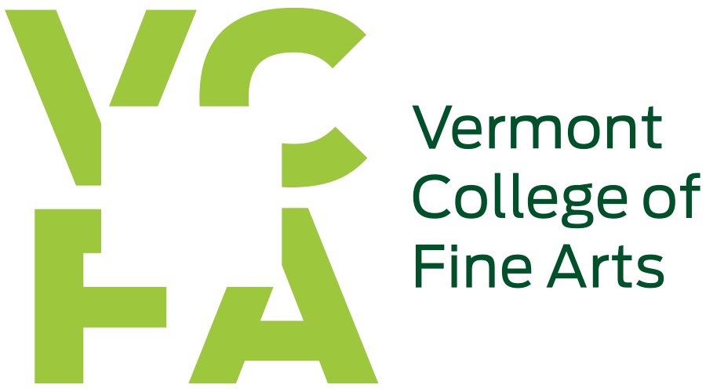

January 14, 2022

Higher Education Emergency Relief Funds Supplemental Support under American Rescue Plan — Student Aid
Under the American Rescue Plan (HEERF III) in June 2021, VCFA became eligible for a third allocation of federal dollars in the amount of $156,620 to provide emergency grants to students. These emergency funds can be used to cover expenses related to the disruption of campus operations due to coronavirus including eligible expenses under your cost of attendance, such as food, housing, course materials, technology, health care, and child care.

VCFA created criteria for eligibility for grant awards based on need and enrollment in degree programs at VCFA in August 2021. Two categories of eligibility were identified which were (1) students with exceptional financial need which is based on Expected Family Contribution (EFC) as reported on their 2021–2022 FAFSAs of 0-999; (2) students who did not meet this criteria, however, had experienced significant financial hardship based on reduced income as a result of the pandemic, could be considered for an emergency grant award by completing a survey requesting their 2020 income and their 2021 projected income. By using the income protection allowance of $57,160 from the 2020–2021 EFC formula for independent students as the proxy for an EFC of 0-999, student requests were evaluated for eligibility for grant awards.

All students were emailed this information about eligibility on September 23, 2021, and, if need be, asked to complete the survey by October 1, 2021. If you are/were a student who was enrolled in August 2021 and had extenuating circumstances that prevented you from acting on the email sent in September, please contact VCFA at finaid@vcfa.edu as soon as possible.

As of October 11, 2021, 94 grants of $1,648.63 each, totaling $154,971, have been issued. As of January 14, 2022, 95 grants of $1,648.63 each, totaling $156,620, have been issued.

As of January 14, 2022, through federal HEERF I, II, and III allocations, 429 emergency grants totaling $298,906 have been issued to VCFA students.

